RELAY DRIVER

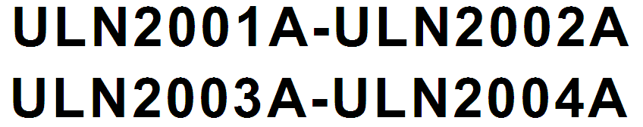

Features:
- SEVEN DARLINGTONS PER PACKAGE
- OUTPUT CURRENT 500mA PER DRIVER(600mA PEAK)
- OUTPUT VOLTAGE 50V INTEGRATED SUPPRESSION DIODES FOR
- INDUCTIVE LOADS OUTPUTS CAN BE PARALLELED FOR
- HIGHER CURRENT
- TTL/CMOS/PMOS/DTL COMPATIBLE INPUTS INPUTS PINNED OPPOSITE OUTPUTS TO
- SIMPLIFY LAYOUT.

DESCRIPTION:

The ULN2001A, ULN2002A, ULN2003 and ULN2004A are high voltage, high current darlington arrays each containing seven open collector darlington pairs with common emitters. Each channel rated at 500mA and can withstand peak currents of 600mA. Suppression diodes are included for inductive load driving and the inputs are pinned opposite the outputs to simplify board layout. The four versions interface to all common logic families
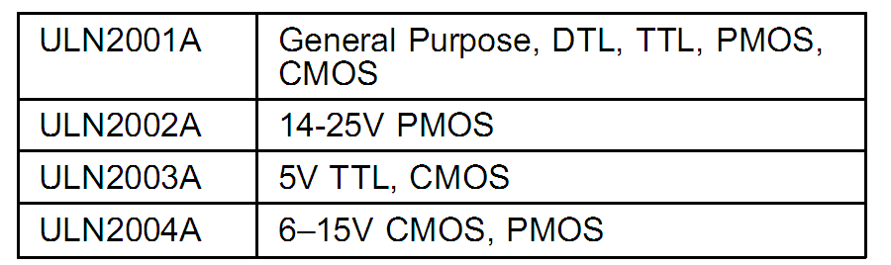

These versatile devices are useful for driving a wide range of loads including solenoids, relays DC motors, LED displays filament lamps, thermal printheads and high power buffers. The ULN2001A/2002A/2003A and 2004A are supplied in 16 pin plastic DIP packages with a copper leadframe to reduce thermal resistance. They are available also in small outline package (SO-16) as ULN2001D/2002D/2003D/2004D
.